|  | 2814ICT/7003ICT – Data Management / Database Design  School of Information & Communication Technology |
| --- | --- |

**Lab 3.1 Exercise**

**1. Understanding functional dependency**

Given the dependency diagram shown in Figure 1 below, fill up the following table.

**FIGURE 1 Dependency Diagram for Question 1**

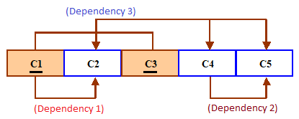

For each of the indicated dependencies in Figure 1, write the type of dependency and briefly explain the reason why this dependency falls into this type.

**Your answer:**

| **Dependencies** | **Dependency types** | **Reasons** |
| --- | --- | --- |
| Dependency 1 | Partial | C2 depends on C1, so C1>C2 represent a partial dependency |
| Dependency 2 | Transitive | C4>C5 represents a transitive dependency because C5 depends on the C4 attribute. |
| Dependency 3 | Functional | C1 and C3 >C2,C4,C5 represents functional dependencies because C2,C4 and C5 depend on C1 and C3 primary keys. |

**2. Finding the normal forms of the tables in an ERD**

For each of the two (2) tables AUTHOR and BOOK_AUTHOR in the ERD below,

1. Write the relation schema, and
2. Draw the dependency diagram and explain in what normal form the table is.

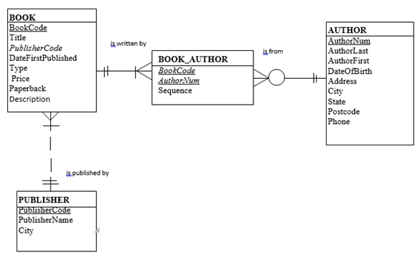

**Your answer:**

1. **Relation schema**

1. AUTHOR (AuthorNum, AuthorLast, AuthorFirst, DateOfBirth, Address, City, State, Postcode, Phone)

2. BOOK_AUTHOR (BookCode, AuthorNum, sequence)

1. **Dependency diagrams and normal forms**

1.AUTHOR

This table is in a 2NF because it has a transitive dependency (and but no partial dependency):

**Full dependency:** AuthorNum ➔ AuthorLast, AuthorFirst, DateOfBirth, Address, City,

State, Phone

**Transitive dependency:** {City, State} ➔ Postcode

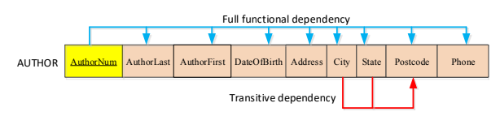

2.BOOK_AUTHOR

The table is in 3NF because it has only the full dependency (and no partial & transitive dependencies)

